Measuring Homeownership in the United States

The homeownership rate is one of the key indicators that we monitor in the Housing Finance Policy Center. The homeownership rate can be a measure of household financial well-being, the state of the housing market, and the overall economic health of the nation. On top of that, racial disparities in homeownership are large, and we are always monitoring the homeownership gap between white households and households of colors.

But what is the best way to measure the homeownership rate? There are several sources of data on homeownership. Since most timely estimates of the homeownership come from survey data, it is important to understand the pros and cons of different measures.

|  |  |  |  |  |  |  |
| --- | --- | --- | --- | --- | --- | --- |
| **Comparing Five Major Measures of the US Homeownership Rate** | | | |  |  |  |
| **Survey** | **Sample Size** | **Frequency** | **Date of last measure** | **Homeownership rate** | **Confidence interval** | **Next update** |
| American Community Survey | Approximately 3.5 million households | Annual | 2018 | 63.9% | (63.8%, 64.8%) | 2019 data will be released in September, 2020 |
| Current Population Survey/Housing Vacancy Survey | Approximately 72,000 households | Quarterly | 2019 Q2 | 64.1% | (63.6%, 64.6%) | 2019 Q3 data will be released in October 2019 |
| American Housing Survey | Approximately 115,00 housing units | Every two years | 2017 | 63.8% | (63.4%-64.2%) | 2019 data will be released in September, 2020 |
| Decennial Census | Full population | Every 10 years | 2010 | 66.9% | -- | 2020 data will be released in December 2021 |
| Annual Social and Economic Supplement | Approximately 72,000 households | Annual |  |  |  |  |

The decennial census is the gold standard in terms of accuracy, since it is a census and not a survey- ideally, the entire nation is included in the sample. However, this occurs only every 10 years. This means that we may miss a lot of the big fluctuations in homeownership- such as the big increases and subsequent declines we saw in the housing boom and bust of the 2000s.

The American Community Survey (ACS) is the largest survey that asks about homeownership, sampling around 3.5 million households annually. From this sample, we can derive estimates (and margin of errors of those estimates) to get a reasonable measure of homeownership. ACS data for the prior year is released in September. Because of the time is takes to collect and process the data, this means that researchers are not always using the most up-to-date estimate.

The Housing Vacancy Survey (HVS), a product of the Current Population Survey, is the most frequently updated indicator, released quarterly. However, the survey has a smaller sample size, of approximately 72,000 households. This creates larger margins of errors, and means that this estimate tends to be more volatile.

Two other surveys, the American Housing Survey (AHS) and the Annual Social and Economic Supplement from the CPS also contain information on homeownership. These surveys have smaller sample sizes than the ACS, and the AHS is only produced every other year.

**Comparing different measures**

To illustrate the differences between measures of homeownership, we can look at two of the most frequently cited measures, the ACS and the HVS. The HVS is frequently cited, since it is the most up to date estimate of the homeownership rate. But, due to the level of volatility, quarterly fluctuations are not always indicative of actual shifts in homeownership.

First, an explanation of some key terms. The Census Bureau makes estimates based of the population that they sample. Since it is just a sample and not the full population, this creates uncertainty. We use the margin of error to measure how much the estimate varies around the true population value- in other words, the level of uncertainty. The Census Bureau reports the margin of error at the 90 percent confidence level. By adding and subtracting the margin of error from the estimate, we can create an interval, in which there is a 90 percent chance that the true value for the population lies within the interval. The smaller the sample, the larger the uncertainty, and therefore the less confident we can be about the validity of the estimate.

The graph of the homeownership rate form the CPS below illustrates these concepts. The dotted lines represent the upper and lower bound of the 90 percent confidence interval for the most recent estimate- in this case, the second quarter of 2019. These lines are useful when we are looking at trends over time. Although it looks like we saw a sharp increase in homeownership at the end of 2018 and then a decline, we can see from the confidence interval that true value may have been relatively consistent with previous quarters.

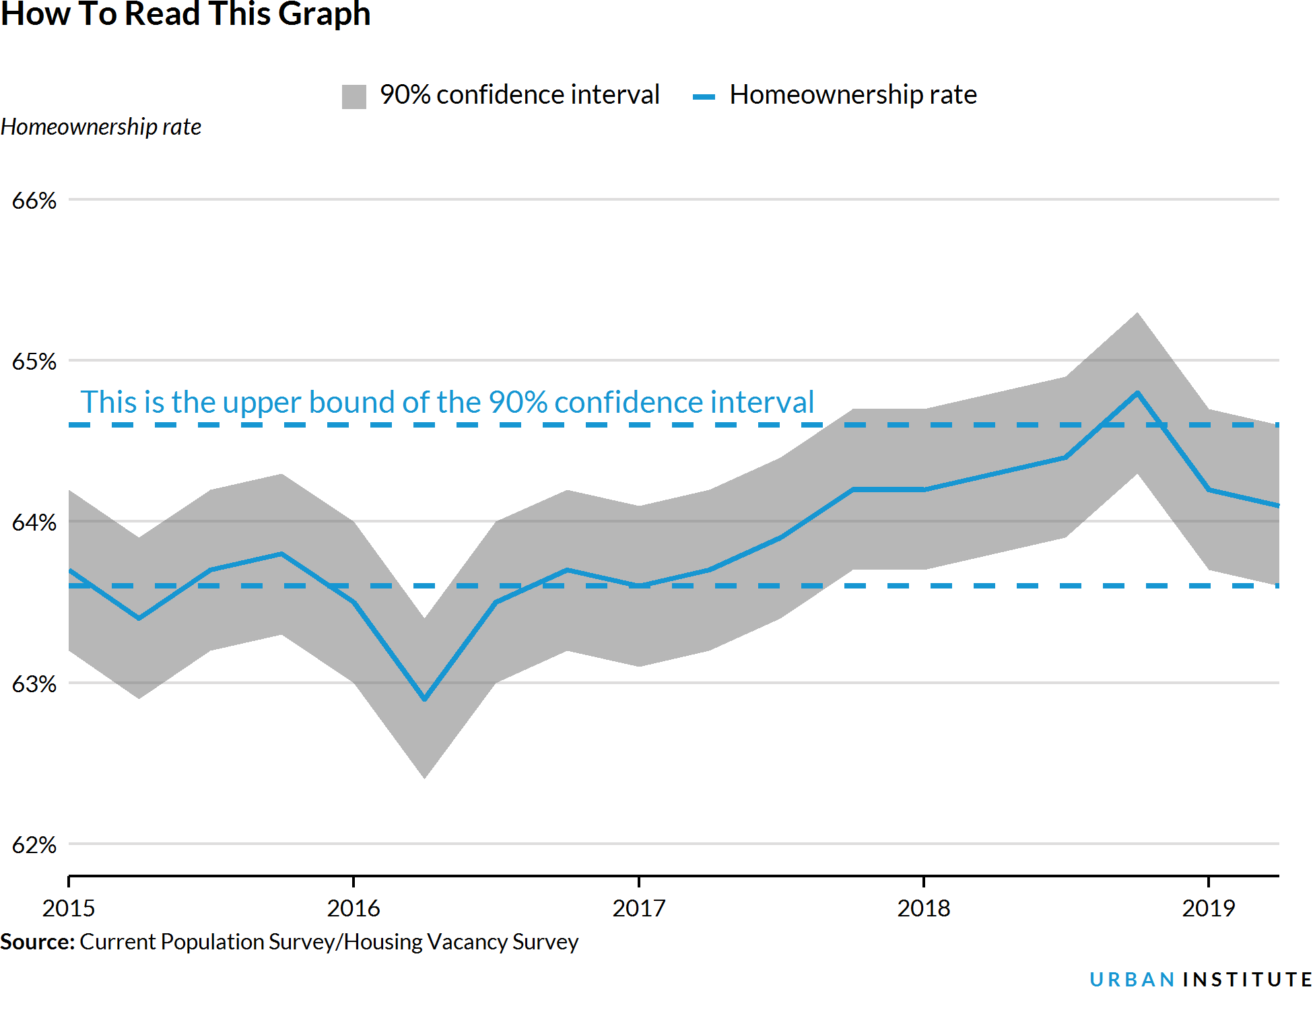

We can now use these concepts to compare the ACS, a large annual survey, with the CPS, a much smaller quarterly survey. You will notice that some of the biggest fluctuations in the CPS homeownership rate do not correspond with drops or rises in the ACS homeownership rate. The confidence interval on the ACS is significantly smaller, due to the much larger sample size. For this reason, we rely on the ACS as our benchmark for homeownership.

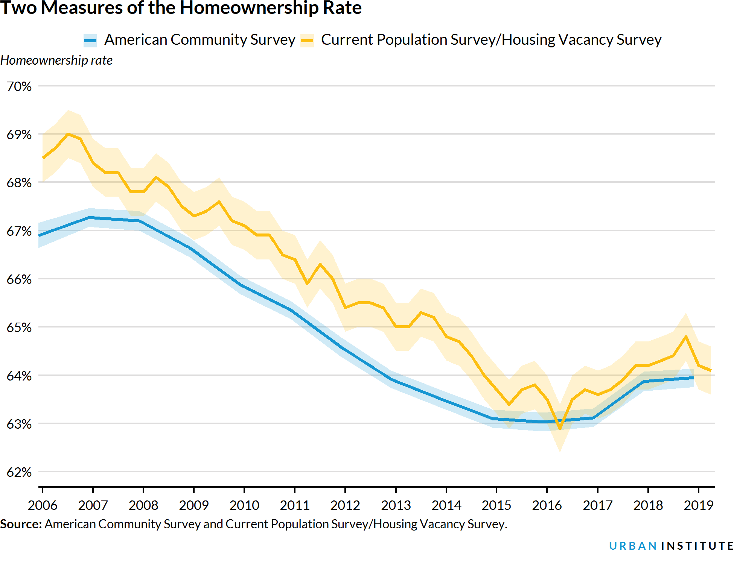

Measuring the homeownership rate requires balancing the frequency of the estimate and the level of uncertainty you are willing to tolerate. More timely measures such as the CPS have merit, but they require more analysis to determine if we are seeing a real trend, or just picking up the volatility in the series. One way to combat this is to compare more than two quarters of data at a time- for instance, instead of looking at the jump from one quarter to the next, look for several subsequent quarters of increases or decreases, or compare the current estimate to the estimate from one year ago, two years ago, and three years ago.